HHC 2007 Example Word Page Layout.
Richard J. Nelson

Delete this text and type or cut and paste your own. The pages will automatically number. Aside from the footer you may do what you wish on your presentation pages. These are just suggestions.  The Margins are 0.7 inches all around. This page was set up showing a dotted line for the margins. It depends on your own settings.  If you put your photos in hidden line tables you will “lock” them in place. This text is in such a table which has its options set to NOT adjust the table size to fit the contents. This allows you to set the width of the table to the desired photo width.  Insert photos do not paste them. This will help keep the file size smaller.  Save this table. Just delete its contents and you will save time if you need it later. Another empty table is also provided below.  If the page numbering is one page too high, etc. because of editing just view as normal and then view as Print Layout and you will force Word to renumber the pages correctly. This is a quirk in most versions of Word.  The space below the photo at the right is 4 points. The figure text is 11 point italics.  The font used here is Times New Roman used because of its space efficiency. The title is 16 point bold.  Again, these are just suggestions. | 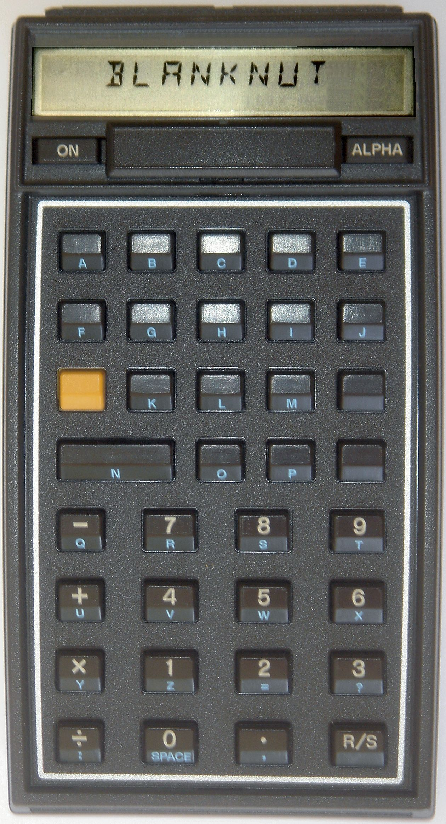  Fig. 1 – HP-41C Blank Nut for custom development.

A useful layout technique is to size your vertical spacing using Ctrl + [ or Ctrl + ]. You may increase or decrease the font size to make titles fit, etc. I used it on the paragraph spacing above to make the last line of text fit on the bottom of the table.

